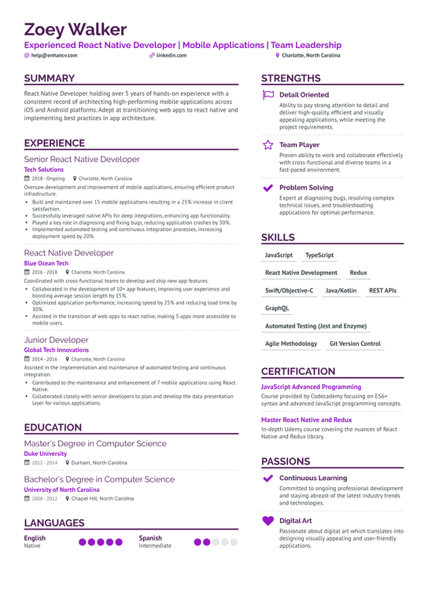
Zoey Walker
Experienced React Native Developer | Mobile Applications | Team Leadership
@help@enhancv.com
SUMMARY
linkedin.com
React Native Developer holding over 5 years of hands-on experience with a consistent record of architecting high-performing mobile applications across iOS and Android platforms. Adept at transitioning web apps to react native and implementing best practices in app architecture.
EXPERIENCE
Senior React Native Developer
Tech Solutions
2018-Ongoing Charlotte, North Carolina
Oversaw development and improvement of mobile applications, ensuring efficient product infrastructure.
• Built and maintained over 15 mobile applications resulting in a 25% increase in client satisfaction.
• Successfully leveraged native APIs for deep integrations, enhancing app functionality. Played a ke a key role in diagnosing and fixing bugs, reducing application crashes by 30%. Implemented automated testing and continuous integration processes, increasing deployment speed by 20%.
React Native Developer
Blue Ocean Tech
2016-2018 Charlotte, North Carolina
Coordinated with cross-functional teams to develop and ship new app features.
• Collaborated in the development of 10+ app features, improving user experience and boosting average session length by 15%
• Optimized application performance, increasing speed by 25% and reducing load time by
30%
•Assisted in the transition of web apps to react native, making 5 apps more accessible to mobile users.
Junior Developer
Global Tech Innovations
2014-2016 Charlotte, North Carolina
Assisted in the implementation and maintenance of automated testing and continuous integration.
• Contributed to the maintenance and enhancement of 7 mobile applications using React Native.
• Collaborated closely with senior developers to plan and develop the data presentation layer for various applications.
EDUCATION
Master's Degree in Computer Science
Duke University
2012-2014 Durham, North Carolina
Bachelor's Degree in Computer Science
University of North Carolina
2008-2012 Chapel Hill, North Carolina
LANGUAGES
English
Native
Spanish
Intermediate
Charlotte, North Carolina
STRENGTHS
Detail Oriented
Ability to pay strong attention to detail and deliver high-quality, efficient and visually appealing applications, while meeting the project requirements.
Team Player
Proven ability to work and collaborate effectively with cross-functional and diverse teams in a fast-paced environment.
Problem Solving
Expert at diagnosing bugs, resolving complex technical issues, and troubleshooting applications for optimal performance.
SKILLS
JavaScript
TypeScript
React Native Development
Redux
REST APIs
Swift/Objective-C Java/Kotlin
GraphQL
Automated Testing (Jest and Enzyme)
Agile Methodology Git Version Control
CERTIFICATION
JavaScript Advanced Programming
Course provided by Codecademy focusing on ES6+ syntax and advanced JavaScript programming concepts.
Master React Native and Redux
In-depth Udemy course covering the nuances of React Native and Redux library.
PASSIONS
Continuous Learning
Committed to ongoing professional development and staying abreast of the latest industry trends and technologies.
Digital Art
Passionate about digital art which translates into designing visually appealing and user-friendly applications.

